**Activate the connection using IAS certificate**

1. Login to SAP LBN.
2. Go to **System Connections** App.

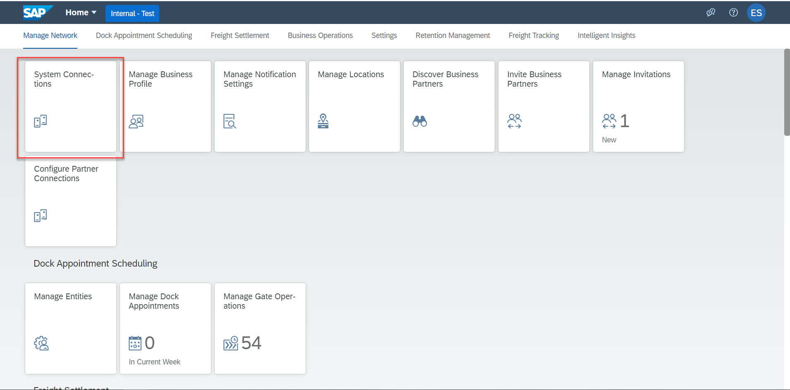

1. Click on Add.

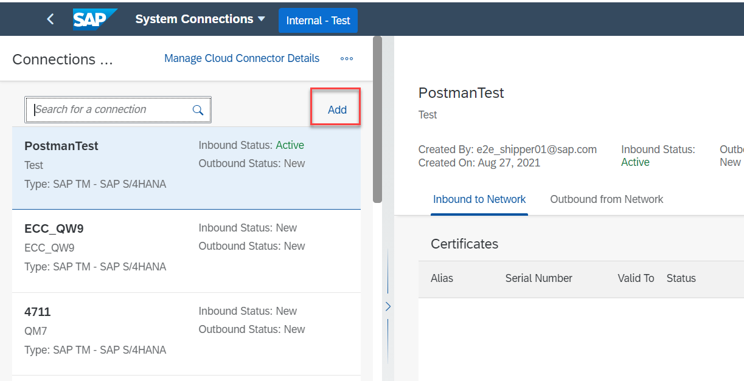

1. Select SAP TM – SAP S/4 HANA from Connection Type.

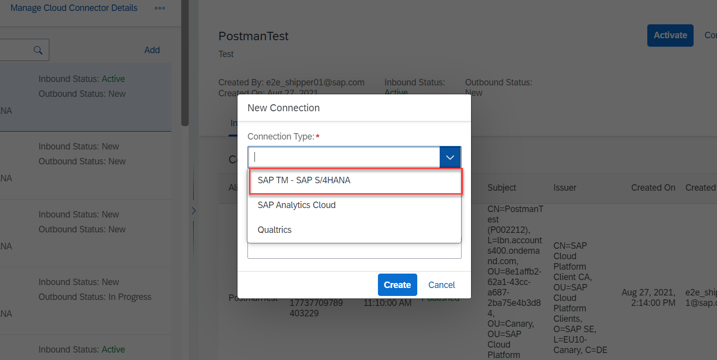

1. Enter the Connection ID and System ID.

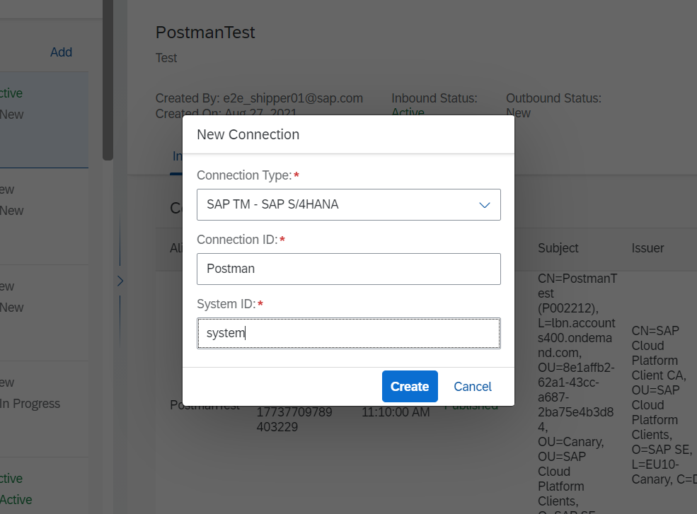

1. Click on Create.
2. Click on Add.

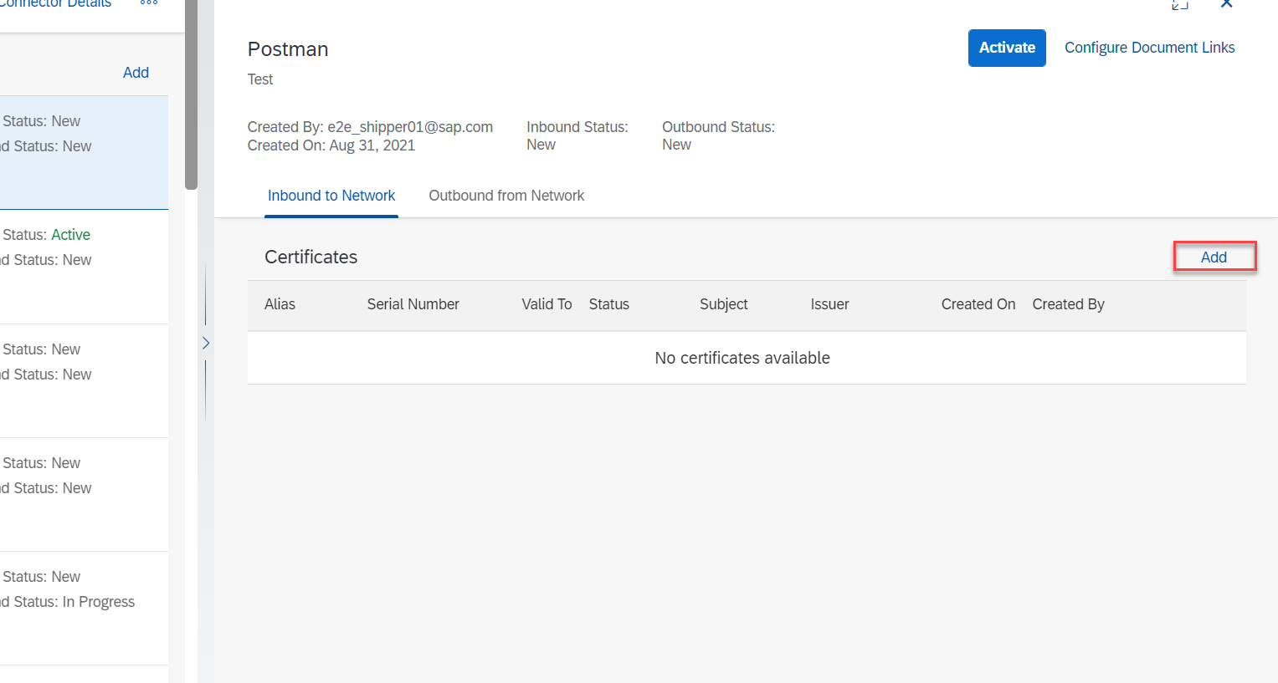

1. Enter an Alias.

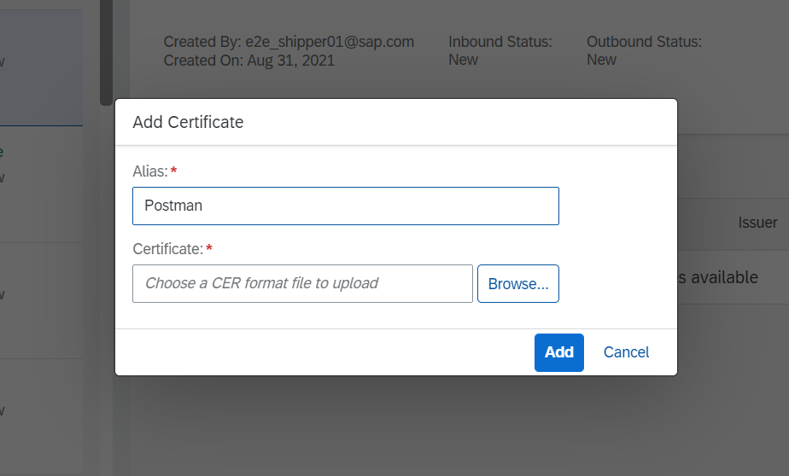

1. Upload the certificate file in **.cer** format. To convert the certificate file in **.cer** format you can use tools like KeyStoreExplorer. Click on Add.
2. Click on Activate.

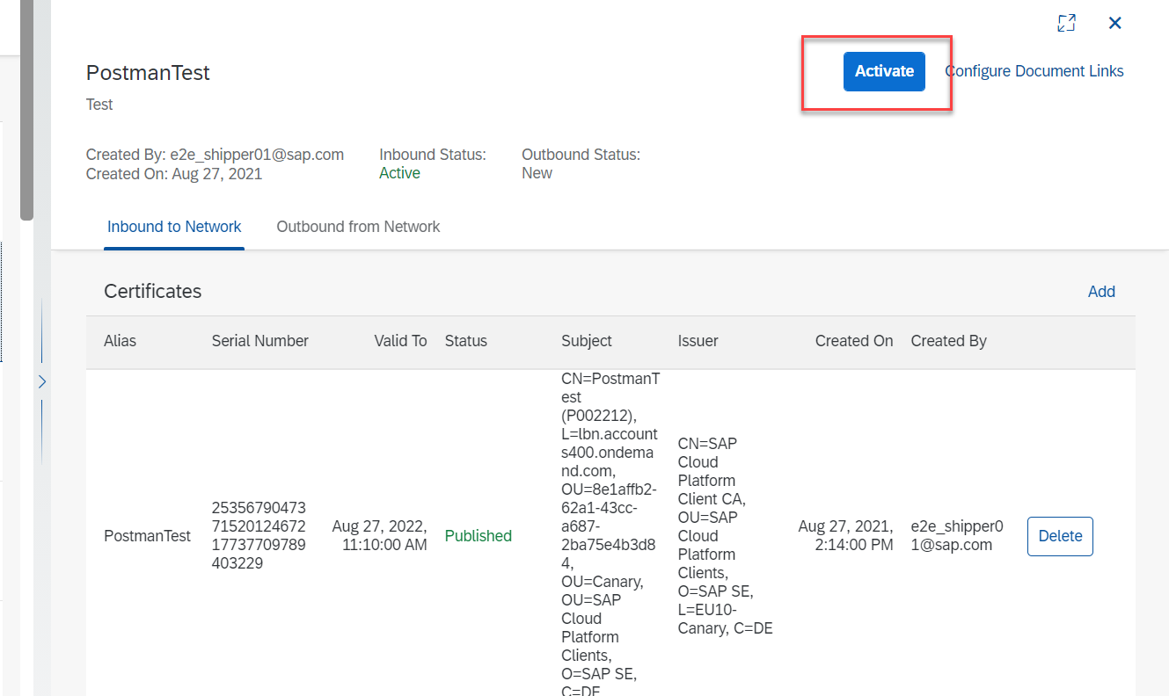

**Configure certificate-based authentication in Postman**

1. Go to settings.

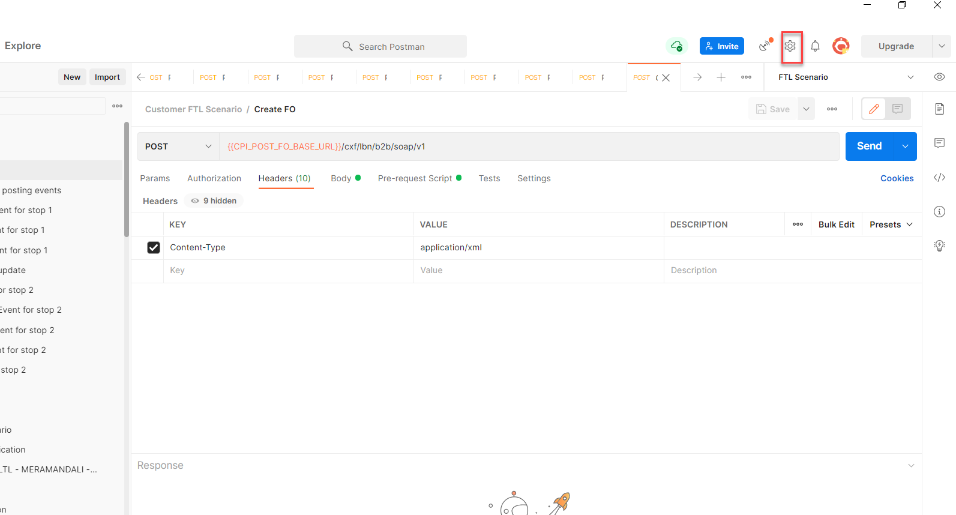

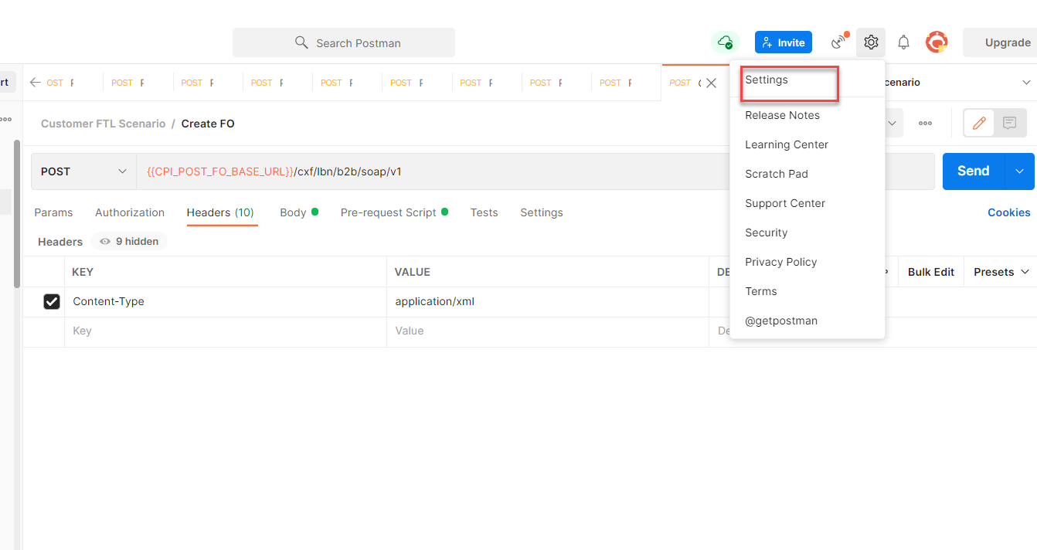

1. Go to certificates and click on Add Certificate.

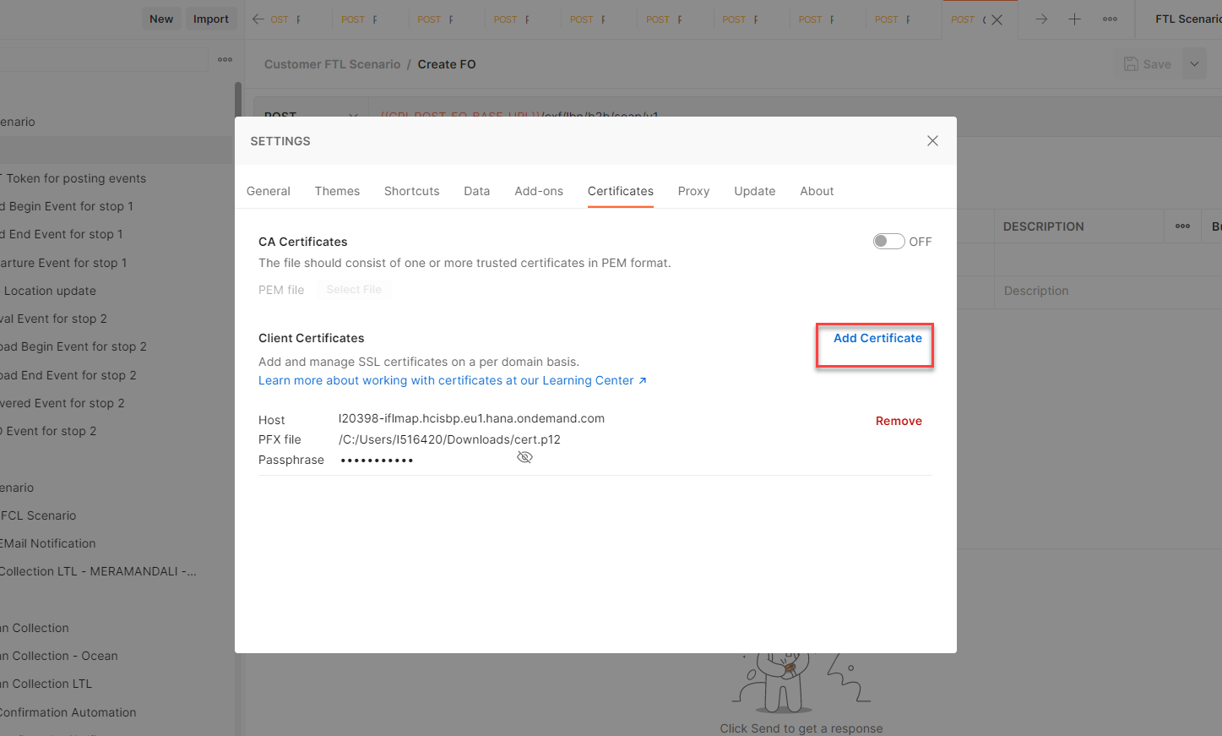

1. Enter the host name as “l20398-iflmap.hcisbp.eu1.hana.ondemand.com”. Upload the **.p12** file in the PFX file along with the passphrase used while creating the certificate.

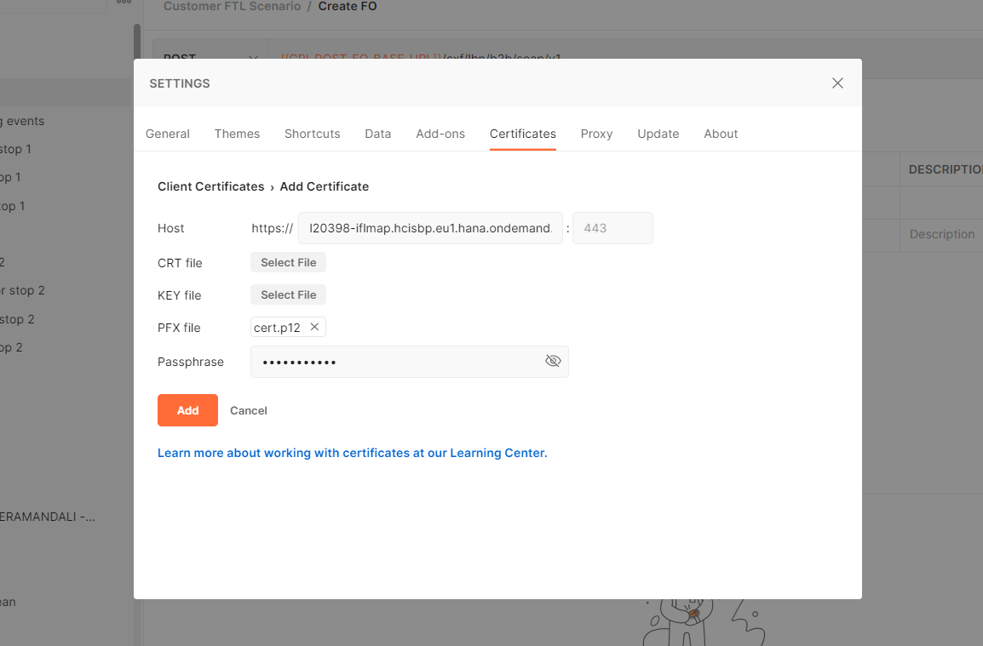

1. Click on Add.